|  |  |
| --- | --- |
|  | TM Forum Open APIs  TM Forum Open APIs are a suite of API interfaces, best practices and design guidelines. TM Forum Open APIs are created in collaboration by service providers, vendors and partners. Although using one API provides value, when combined together the APIs enable end-to-end management through the entire service lifecycle. The APIs provide the management of a service across a number of dimensions; creation to decommission, monitoring, SLA management are examples.  TM Forum Open APIs provide a generic framework of API specifications which can be used for any type of Product, Service and Resource and can be used within the communications and other industries. The adoption of the Open API specifications enable ecosystems like IoT device management, complex B2B value fabrics. APIs manage partner arrangements across business boundaries. They provide the specification of the interface for on-boarding, SLA management, policy management and revenue sharing and settlement.  **Key concepts of TM Forum Open APIs**  **TM Forum Open APIs and Microservices**  **TM Forum Open API Map**  **TM Forum Open APIs enable platforms**  **TM Forum Open Data Model** |

# Key concepts of TM Forum Open APIs

* Recognize the presence of multiple partners that need to share information
* Define a core service model
* The core model is extended to provide the management capability for a specific type of service
* Any product, service or resource can be managed with a set of APIs

|  |  |
| --- | --- |
| TM Forum Open APIs and Microservices TMForum Open APIs have been purposefully designed to support their implementation as microservices. This further aligns the TM Forum Open APIs with the TELUS target architecture that includes the application of a microservice architecture and the adoption of the domain model. |  |

# TM Forum Open API Map

The TM Forum Open API Map builds on the domain map to provide a reference for the TM Forum Open APIs that are applicable within each domain of the TM Forum Frameworx. As APIs are continually being added, the master view can be found within the TM Forum Open API project. This view is included as an example and to reinforce the concept that an API provides capabilities within one domain.

#### 

# TM Forum Open APIs enable platforms

The open APIs are the common integration language of the enterprise. Consumers of capabilities are only required to understand the universal language in order to leverage any capabilities of the enterprise. This common language, being an industry standard, also provides interoperability with external parties which need to interact with the enterprise.

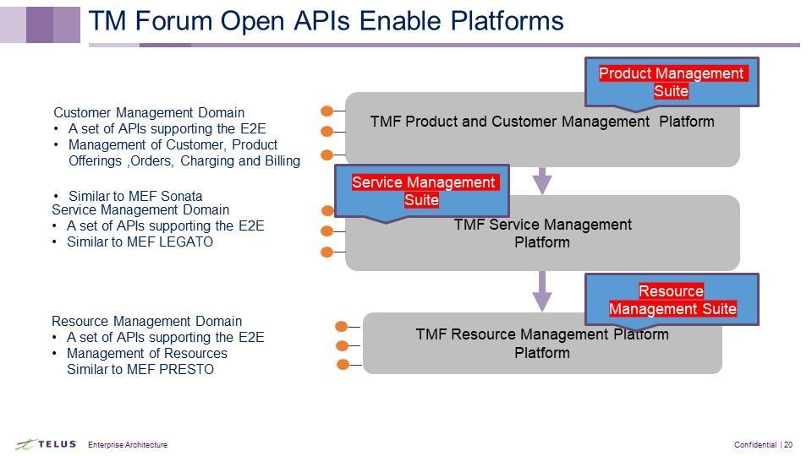

A component suite of APIs can be used to fulfill an end to end business process. For example: the Self-Care Suite identifies the API operations required to manage customer self-care through the lifecycle. The following shows the APIs and operations that are part of the Self-Care Suite. The component suites assist in identifying the core APIs and operations that are required to fulfill the end to end process.

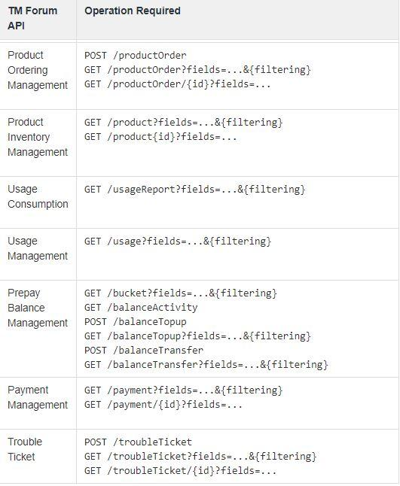

# TM Forum Open Data Model

The TM Forum Open API Data Model is another key component to the Reference Architecture. The TM Forum Open API Data Model contains the definitions of the common Open API data model. APIs either include entities of the common data model or reference the common data model entities within the JSON representation of their payload. Moving towards the use of a common data model contained within JSON schemas supports interoperability and improves the data quality of information exchanged between platforms. As part of the adoption of Open API Data Models a repository for common schemas must be created and a governance process around schemas created and maintained. The details of the repository and governance are contained within the design best practices.

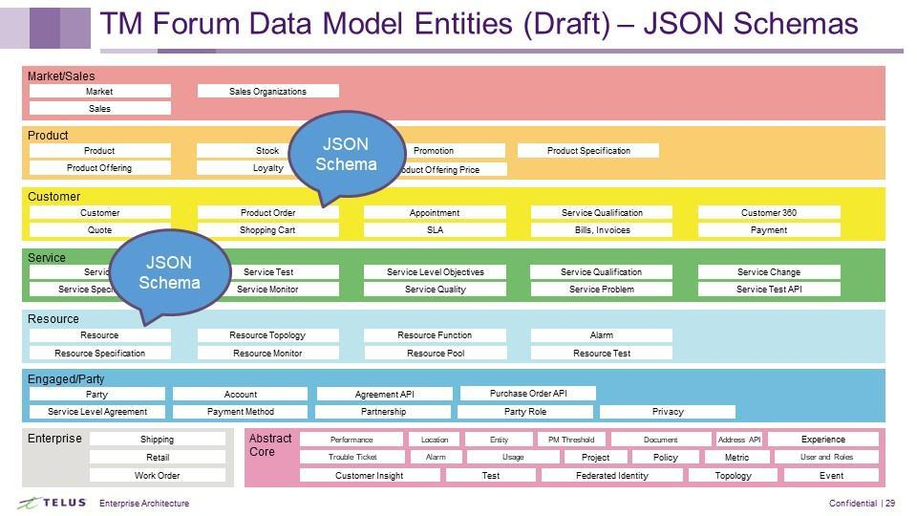

## Example schema

file://apitools.tsl.telus.com/Open_API_And_Data_Model/schemas/Customer/Customer.schema.json

{

"$schema": "http://json-schema.org/draft-07/schema#",

"$id": "Customer.schema.json",

"title": "Customer",

"definitions": {

"Customer": {

"$id": "#Customer",

"type": "object",

"required": [

"engagedParty"

],

"properties": {

"href": {

"type": "string",

"description": "Url used to reference the customer."

},

"id": {

"type": "string",

"description": "Unique identifier for Customers"

},

"name": {

"type": "string",

"description": "A word, term, or phrase by which the Customer is known and distinguished from other Customers."

},

"status": {

"type": "string",

"description": "Used to track the lifecycle status of the customer."

},

"statusReason": {

"type": "string",

"description": "A string providing an explanation on the value of the status lifecycle. For instance if the status is Rejected, statusReason will provide the reason for rejection."

},

"validFor": {

"$ref": "../Common/TimePeriod.schema.json#TimePeriod",

"description": "The time period that the Customer is valid for."

},

"engagedParty": {

"$ref": "../EngagedParty/RelatedParty.schema.json#RelatedParty",

"description": "The party - an organization or an individual - that is engaged as a customer."

},

"account": {

"type": "array",

"items": {

"$ref": "../EngagedParty/AccountRef.schema.json#AccountRef"

}

},

"paymentMethod": {

"type": "array",

"items": {

"$ref": "../Customer/PaymentMethodRef.schema.json#PaymentMethodRef"

}

},

"contactMedium": {

"type": "array",

"items": {

"$ref": "../Common/ContactMedium.schema.json#ContactMedium"

}

},

"characteristic": {

"type": "array",

"items": {

"$ref": "../Common/Characteristic.schema.json#Characteristic"

},

"description": "Describes the characteristic of a customer."

},

"creditProfile": {

"type": "array",

"items": {

"$ref": "../Customer/CreditProfile.schema.json#CreditProfile"

}

},

"agreement": {

"type": "array",

"items": {

"$ref": "../EngagedParty/AgreementRef.schema.json#AgreementRef"

}

},

"relatedParty": {

"type": "array",

"items": {

"$ref": "../EngagedParty/RelatedParty.schema.json#RelatedParty"

}

}

},

"allOf": [

{

"$ref": "../Common/Entity.schema.json#Entity"

}

]

}

}

}